**A**

**Project-I Report on**

**“Opulence: An Expense Tracker”**

In partial fulfillment of requirements for the degree of

**Bachelor of Technology (B. Tech.)**

in

**Computer Science and Engineering**

**Submitted by**

Ms. Bhakti Yadav (190106)

Ms. Deepansha Singh (190110)

Ms. Samyukta Singh (190123)

**Under the Guidance of**

Dr. Ajay Kumar

*Department of Computer Science and Engineering*

**SCHOOL OF ENGINEERING AND TECHNOLOGY**

**Mody University and Science and Technology Lakshmangarh, Distt. Sikar-332311**

December 2021

**A C K N O W L E D G E M E N T**

Presentation, inspiration, and motivation have always played a vital role in the success of any venture.

With immense pleasure, we present **“Opulence: An Expense Tracker”** as a part of the curriculum of “Bachelors of Technology B. Tech (Year 3)”.

We take this opportunity to acknowledge everyone who has backed us to contribute to the development of this project.

We express our profound thanks to the Dean-SET, Dr. Rajeev Mathur, for providing us with this opportunity to learn and grow.

We are especially very grateful to Dr. Ajay Kumar, our project mentor, for his guidance, inspiration, motivation, and encouragement during the project study. He has been patient while listening to the queries and solving them, despite having a busy schedule.

We are also very thankful to our friends and family for their constant support.

**Bhakti Yadav (190106)**

**Deepansha Singh (190110)**

**Samyukta Singh (190123)**

**CERTIFICATE**

This is to certify that the minor project report entitled “Opulence: An Expense Tracker” submitted by Ms. Bhakti Yadav, Ms. Deepansha Singh, Ms. Samyukta Singh, as a partial fulfillment for the requirement of B. Tech. Vth Semester examination of the School of Engineering and Technology, Mody University of Science and Technology, Lakshmangarh for the academic session 2021-2022 is an original project work carried out under the supervision and guidance of Dr. Ajay Kumar has undergone the requisite duration as prescribed by the institution for the project work.

**PROJECT GUIDE: HEAD OF DEPARTMENT**

**Signature: Signature:**

**Name: Dr. Ajay Kumar Name:**

**Date: Date:**

**EXAMINER-I: EXAMINER-II**

**Signature: Signature:**

**Name: Name:**

**Date: Date:**

**ABSTRACT**

“Knowledge is of no value unless you put it into practice.”

-Anton Chekhov

While looking for ways to incorporate our theoretical understanding of Machine Learning into applications that solve everyday real-life problems, we aim to integrate an interdisciplinary model working on computer vision and natural language processing into a Flutter application that appeals to a mass audience.

As college students, one of our biggest concerns is how to manage our allowance money. Hence the plan is to build an application for expense tracking to monitor our day-to-day transactions.

Thus, Opulence: a day-to-day expense tracking app.

Opulence aims to figuratively help you achieve its literal meaning, great wealth, and luxuriousness by undertaking small and conscious efforts to track every time you spend any amount.

**Table of Contents**

|  |  |  |
| --- | --- | --- |
| **Sr.no.** | **Topics** | **Page no.** |
| **1.** | **Introduction** | **1** |
| 1.1 | -*Present System* | 1 |
| 1.2 | *-Proposed System* | 3 |
| **2.** | **System Design** | **5** |
| 2.1 | *-User Flow Diagram* | 5 |
| **3.** | **Software details and Hardware** | **6** |
| 3.1 | * *Software Details* | 6 |
| 3.1.1 | * *Technical Stack* | 6 |
| 3.1.1.1 | * + *Flutter Framework* | 6 |
| 3.1.1.2 | * + *Dart* | 7 |
| 3.1.1.3 | * + *Google ML Kit* | 8 |
| 3.1.1.4 | * + *Groovy* | 8 |
| 3.1.2 | * *Tools* | 9 |
| 3.1.2.1 | * + *Adobe Illustrator* | 9 |
| 3.1.2.2 | * + *Figma* | 9 |
| 3.1.2.3 | * + *Google Forms* | 10 |
| 3.1.2.4 | * + *VS Code* | 10 |
| 3.1.2.5 | * + *Jupyter Notebook* | 10 |
| 3.1.2.6 | * + *Android Studio* | 11 |
| 3.1.2.7 | * + *Emulator* | 11 |
| 3.1.3 | * *Version Control* | 12 |
| 3.1.3.1 | * + *GitHub* | 12 |
| 3.2 | * *Hardware Details* | 13 |
| 3.2.1 | * + *Samsung Galaxy A22 5G* | 13 |
| 3.2.2 | * + *LYF WaterF1* | 14 |
| **4.** | **Implementation Work Details** | **15** |
| 4.1 | * *Real life applications* | 15 |
| 4.2 | * *Data implementation and program execution* | 16 |
| * *Contribution to Society* | 18 |
| **5.** | **Code Snippets** | **20** |
| * *Widgets* | 20 |
| **6.** | **Input and output Screens** | **23** |
| **7.** | **System Testing** | **27** |
| * *Multi Media Query* | 27 |
| * *Scan Feature Accuracy* | 27 |
| **8.** | **Individual Contribution** | **28** |
| **9.** | **Conclusion** | **29** |
| 9.1 | * *-Limitations* | 29 |
| 9.2 | * *-Scope for future work* | 29 |
| **10.** | **Bibliography** | 30 |
| **11.** | **Annexures** |  |
| 11.1 | * *Publication Communicated or Published* |  |
| 11.2 | * *Plagiarism Report* |  |

**List Of Figures**

|  |  |  |
| --- | --- | --- |
| **Sr.no.** | **Figure Name** | **Page no.** |
| **1.** | Selected reviews from various applications on Google PlayStore | 3 |
| **2.** | User Flow Diagram | 5 |
| **3.** | Samsung Galaxy A22 5G Model | 13 |
| **4.** | LYF Water F1s Model | 14 |
| **5.** | Survey Question – Your age range | 18 |
| **6.** | Survey Question - Which category do you best fit into? | 19 |
| **7.** | Survey Question – Do you usually like to keep track of your everyday receipts and bill? | 19 |
| **8.** | Logo Placement on Landing Page | 20 |
| **9.** | Bottom Navigation | 20 |
| **10.** | Transaction Detail Widget – Transaction Title | 21 |
| **11.** | Transaction Detail Widget – Amount | 22 |
| **12.** | Sign In/ Sign Up Page of Opulence | 23 |
| **13.** | Add Transaction Page of Opulence | 23 |
| **14.** | Manual Add Transaction Details Page of Opulence | 24 |
| **15.** | All the Transactions added by the user are displayed on this page | 24 |
| **16.** | Asking for camera Access | 25 |
| **17.** | Saving the image clicked | 25 |
| **18.** | Loading Page | 26 |
| **19.** | Home Page | 26 |
| **20.** | LYF Water F1 Screen | 27 |
| **21.** | Samsung Galaxy A22 5G Screen | 27 |

**Chapter1: Introduction**

1. **INTRODUCTION**

In the era of organization and minimalism, expense tracking mobile applications are popular globally. The most frequent user include students of all age groups wanting to manage their basic monthly allowances to make the best out of the limits, home-makers trying to work around household expenses while saving at the same time.

We have developed an expense tracking application that helps replace log-keeping for the general audience and declutter wallets from receipts.

Primary features of the application include:

* Budget and Bill Organizing
  + Record all items in transactions with different categories and amounts by scanning the receipts using a Deep Learning model and storing them in the cloud.
* The Whole Picture in One Place
  + A clear view of the user’s financial life; better understanding of where their money comes and goes with visualized reports about income, expense by time, and category.
* Spending / Income Pie Chart
  + Provide elaborate expense distribution using easy-to-understand infographics classified under personalized categories.

The entire design activity, from ideation to final prototyping, was done using Figma. In our project, we use Flutter: a mobile application framework by Google; for building our codebase. The project has an integrated scan feature that helps the application stand out and be more efficient.

* 1. **PRESENT SYSTEM**

There is a varied spectrum of mobile applications serving as expense trackers. The concept is a popular topic amongst students trying to experiment with various tech-stacks and hence has an entire market it serves.

On further analyzing a few highly-rated, randomly selected applications from Google PlayStore, we came up with the following conclusions by our first-handing testing and the reviews on the application page:

* Developers have neglected the importance of pleasurable and easy-to-use user interface designs.
* There is no general weightage of user experience, making it difficult to use the applications initially.
* Most available applications have the feature of categorizing expenses and transactions fed into the account but fall short in its implementation.
  + There have been reported issues on the editability and customizability of the feature.
  + Quite a few times, the feature has failed to load and organize the transactions entirely, implying a lack of trustable implementation.



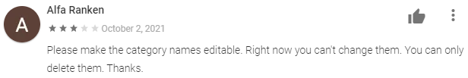

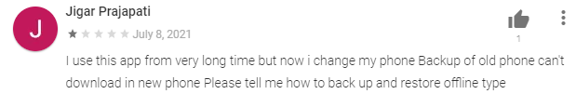

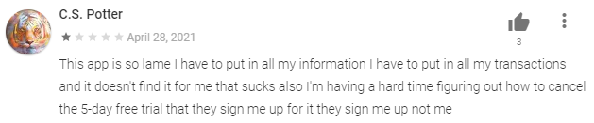

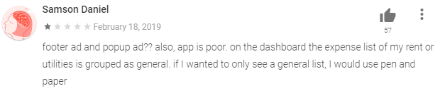

Fig. 1: Selected reviews from various applications on Google PlayStore

* 1. **PROPOSED SYSTEM**

With the ever-rising interest and options of living meticulously, expense-tracking has been gaining rapid importance among the youth. Despite a flourishingly overriding market of choices available, there have been considerable drawbacks. Keeping in mind the setbacks faced by our predecessors, as mentioned in the previous section. *(see 1.1 Present System)* we have improved on a plethora of features in our application.

Highlight features of Opulence that help it stand out among the masses include:

* Budget and Bill Organizing
  + Record all items in transactions with different categories and amounts by scanning the receipts using a Deep Learning model and storing them in the cloud.
  + Get a personalized logbook customized individually for each user.
* The Whole Picture in One Place
  + A clear view of the financial life; better understanding of where their money comes and goes with visualized reports about income, expense by time, and category.
  + Hassle-free money-management.
* Spending / Income Pie Chart
  + Provide elaborate expense distribution using easy-to-understand infographics classified under custom categories unique to each user.
* Refined user interface and experience
  + Utmost emphasis has been given to proper usage of psychology (white space directive, icons, etc.) and design while designing the mock-ups for the application.
  + The user and his task of log-keeping are over fancy and dazzling design patterns and trends.
  + The primary concept of minimalism and decluttering has been a key focus during the entire design process.
* Scan receipt feature
  + A coming-of-the-age OCR model is integrated into the application to aid the user in tracking their receipts better.
  + It uses the trusted technology by Google via the official Google ML kit.
* Dynamically viewable portrait mode application:
  + Using the screen dynamism ability of Flutter, the application aims to serve the best quality experience to the users.

**Chapter 2: System Design**

* 1. **USER FLOW DIAGRAM**

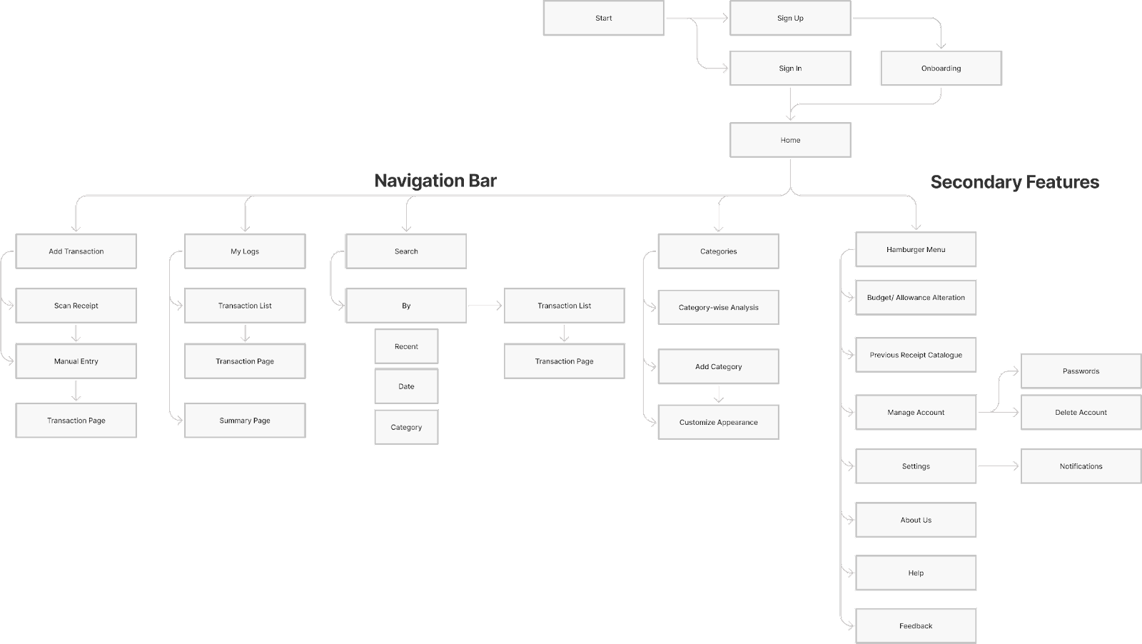

Fig. 2: User Flow Diagram

**Chapter 3: Software and Hardware Details**

* 1. **SOFTWARE DETAILS**
     1. **TECHNICAL STACK**
        1. **FLUTTER FRAMEWORK**

A mobile operating system, called Android was developed by Google. The Linux kernel supports the Android OS. Its primary application is for touchscreen mobile devices such as smartphones, but it's also seen in televisions and wristwatches. Under open-source licenses, Google released Android source providing free access to everybody. As a result, plethora of developers use the open-source code as the bedrock for community-driven projects.

The framework we are using for the development of our expense tracker application - Opulence is Flutter. Flutter is a mobile application development framework delivered by Google for building mobile, web, and desktop applications. This technology is a jackpot for cross-platform app development. It is not a library or framework utilized with other technologies, but rather a UI software development kit (SDK).

A library is a treasury of code used in an app to execute a specific function. On the other hand, a framework serves as a framework for future apps by offering tools to complete the design. An SDK is a collection of tools, such as libraries, frameworks, documentation, and APIs, which can be used to develop a fully functional application.

**Why Flutter?**

Reasons why we decided to use the Flutter framework for our app development:

1. **Cross-platform app development:** If you're new to app development, the volume of information on how to start building an Android app or launch an iOS app might be intimidating. Why not develop apps for both iOS and Android? Flutter provides you exposure to simple cross-platform mobile app development tools that save you time and mitigate the issues that arise with developing two apps at the same time. Your task will be a lot easier if you have a single codebase for both platforms.
2. **It's fast:** The game-changer when it comes to mobile app development is speed. For developers, here's how Flutter hits the mark: Any modifications to the code are immediately reflected in the app. The above process is addressed as the "hot reload" by Flutter and described as follows: Flutter's hot reload feature allows you to experiment, develop UIs, add features, and correct errors fast and painlessly.
3. **Top-notch user experience:** Using ready-made widgets to construct apps is what Flutter app development is all about. Flutter's widget style, as distinguished from other typical approaches like layouts, views, or controllers, enables a consistent object model and an easy development process. Everything you touch in Flutter development is a widget, from buttons to fonts, and widgets may be fused to create more intricate layouts. Developers of Flutter apps get access to a large number of widgets that may be reused and altered to build beautiful user interfaces. However, Flutter's widgets are structured in trees. Therefore, it is critical to prepare ahead of time if you are creating a huge app.

**Building the user interface**

The user interface in Flutter is entirely composed of widgets. Everything is just a widget, and the user interface is produced by layering widgets. Text, buttons, rows, columns, and containers are among the most basic and often used widgets supported by the framework. In Flutter, primary UI development is building custom widgets using the existing widgets to match the desired design.

In Flutter, widgets can be stateful or stateless. The primary contrast between these two is that the stateless widget is immutable and is only constructed once during the creation of the widget instance. The changeable stateful widget, on the other hand, will be recreated whenever its state changes.

Flutter offers convenience widgets for both Material Design and Cupertino Design as the upper widget. These widgets provide functionality and user interface components that are shared by these design systems. If neither of the two design systems is employed in the apps, the WidgetsApp widget becomes the upper widget. WidgetsApp supplies necessary widgets for an application, according to the official specification.

* + - 1. **Dart**

Dart is a free, open-source, object-oriented programming language with a C-like syntax. Google was and continues to be, the primary developer of Dart. Dart programming is used to develop Flutter applications.

Dart is a programming language as well as a mobile app development platform. It's used to develop just about everything on the web, servers, desktops, and, of course, mobile apps.

Unlike other programming languages, it supports most of the basic programming concepts such as classes, interfaces, and functions. Arrays are not natively supported by the Dart language. It has a collection feature that allows you to duplicate data structures like arrays, generics, and optional types.

* + - 1. **Google ML Kit**

ML Kit is a mobile SDK that brings Google's machine learning expertise to Android and iOS apps in a powerful yet easy-to-use package.

SDK or a software development kit is a collection of software development tools in one package. It is also known as a devkit and is platform-specific. It usually contains tools like compilers, code samples, code libraries, testing, and analytics tools, documented, debuggers. At least one API is included in the SDK as without the API applications cannot relay information and work together.

API or application programming interface sits between the application and the web server acting as an intermediary layer that processes data transfer between systems.

**How does an API work?**

A client requests to get information, also known as API call. The API call is processed from an application to the web server through the API’s Uniform Resource Identifier (URI).

After getting a valid request, the API makes a call to the external program or web server.

The server sends a reply with the requested information.

The API transfers the data to the initial requesting application.

With just a few lines of code, the functionality required can be implemented. If you are a beginner, you do not need to have in-depth knowledge of neural networks or model optimization to get started. On the other side of the coin, if you are an experienced ML developer, it provides convenient APIs.

* + - 1. **GROOVY**

Java is a widely used object-oriented programming language.

Apache Groovy is a Java-syntax-compatible object-oriented programming language for the Java platform. It is both a static and dynamic language with features similar to Python, Ruby, and Smalltalk.

A static programming language is compiler-based programming.  We must specify the data type of its variable before using it in your code and cannot change the data type after declaration.

A dynamic programming language is a high-level programming language, which executes many common programming behaviors at runtime that static programming languages perform during compilation.

* + 1. **TOOLS**
       1. **ADOBE ILLUSTRATOR**

Adobe Illustrator is a multi-decade popular tool among designers developed and marketed by Adobe Systems. It is a vector-graphic software used for creating magic in layman terms.

The industry-standard software helps designers create high-resolution logos, illustrations, icons, modern typography, and whatnot.

Packed alongside a power-bunch in the Adobe Creative Cloud subscription, Illustrator is one of the most commonly used helping hands for anything brand design.

Loaded with an impressionable toolkit, Illustrate is the modern Messiah of artists and brand designers. It comes with an array of features, including selection, pen, pencil, and paintbrush tools, to name some. The software not only allows one to create new illustration pieces from scratch but also edit pre-existing ones.

* + - 1. **FIGMA**

Figma is a free and flourishing young competition to names like Sketch and Adobe XD. Having first released in 2016, Figma is an online design and prototyping tool. It is essentially a web-based application that has a feebly popular Desktop version as well.

A comparatively rarer name yet is equally competitive and now almost a par, if not better than most decade-settled industry experts. With its power-packed features and rapid releases, it has created an evident user base from its initiation.

Its easy-to-use and understandable services and features are real-life examples of the purpose they urge they serve. It is a collaborative design mock-up tool for groups of all sizes. True to its commitment, Figma has been steadily improving. Its immense popularity results from the fascination of millions of designers, professionals, and students alike with the tool.

* + - 1. **GOOGLE FORMS**

Google Forms is a survey service by Google that is free for each associated Google account. It is an integral part of the Google Docs Editor suite alongside popular service names like Slides, Docs, Keep, etc.

It is small, precise, yet crisp, cloud-based software that allows one to create, edit and circulate forms and surveys. The recent updates also include creating quizzes and so with multiple question types and pre-grade each question.

It is a free and easy go-to for small-scale research surveys by designers to get the public opinions and viewpoints to base their design decisions.

It is a more feasible option compared to a questionnaire, email-writing formats of surveys. In case of a long answer requirement, there are options for getting small paragraphs and full-length answers from the audience.

* + - 1. **VS CODE**

In layman's terms, Visual Studio Code is a code editor. Visual Studio Code is a "free editor that assists programmers in writing code, debugging, and correcting code using the intelli-sense approach." In simpleton's words, it makes it easier for users to develop code. Many people claim it's half an IDE and half an editor, but that's up to the developers to decide. Any program/software we see or use is based on code that runs in the background. Traditionally, coding was done in traditional editors or even in simple editors like notepad! These editors used to give rudimentary assistance to developers.

Until recently, there has scarcely been an IDE or code editor that has been so user-friendly that even inexperienced users can utilize every function without difficulty. The coding-friendly feature and code error detection also go a long way toward making the code more efficient and error-free.

* + - 1. **JUPYTER NOTEBOOK**

The Jupyter Notebook is an open-source web application that allows you to create and share notebooks that integrate live code, equations, computational output, visualizations, and other multimedia resources, along with explanatory text in a single document.

The notebook has two parts:

**Web application:**  a browser-based tool for interactive authoring of documents that combine explanatory text, mathematics, computations, and their output.

**Notebook Documents:** a representation of all content visible in the web application, including inputs and outputs of the computations, explanatory text, mathematics, images.

* + - 1. **ANDROID STUDIO**

Android Studio is the official integrated development environment (IDE) for developing Android applications. It is built on IntelliJ IDEA, a Java-based integrated development environment for software, and includes its code editing and developer tools.

Android Studio is a single platform for developing apps for Android phones, tablets, Android Wear, Android TV, and Android Auto. Organized code modules allow you to break your project into functional components that you can create, test, and debug separately.

Among the features of Android Studio is a ready-to-use Gradle-based framework that is both flexible and simple to use. It is built using a range of various APK versions throughout the course of multiple generations.

* + - 1. **EMULATOR**

It allows developers to test URLs as well as other technologies on the operating system and display the interface of a mobile device. Many experts regard the usage of a mobile emulator to be essential for development.

Every computer and operating system is one-of-a-kind. A software or app that runs on one platform may/may not run on another. This is especially true when contrasting operating systems such as Windows and macOS, or devices such as a laptop and a PlayStation. Emulators are helpful in this regard. Emulators can act as a bridge between various devices, allowing applications to run on a multitude of platforms.

* + 1. **VERSION CONTROL**
       1. **GITHUB**

GitHub is an open-source code hosting site that is used for version control and collaboration. Cloud source code storage supports all mainstream programming languages and speeds the iteration process. It enables you to collaborate with others on projects from anywhere. It's a social networking site for programmers.

A large number of programmers are given the opportunity to download and evaluate each other's code. It enables collaboration by allowing you to fork projects, send and pull requests, and track progress.

Version control improves efficiency without altering the software itself. It is a contemporary development platform with over 73 million developers as acquaintances or users, as well as over 200 million repositories. You might argue it's where the world's software is created.

Repositories are similar to parent files in that they include all of our program files as well as their modification history. There are two kinds of repositories: public and private.

Everyone has access to a public repository. The owner can provide others additional degrees of authority, such as the ability to push commits. Everyone can't see a private repository. The owner can grant others read, write (push), or admin access.

* 1. **HARDWARE DETAILS**

**3.2.1 SAMSUNG GALAXY A22**

Dimensions: 159.3 x 73.6 x 8.4 mm

Display Type: Super AMOLED, 90Hz, 600 nits (HDR)

Size: 6.4 inches

Resolution: 720 x 1600 pixels, 20:9 ratio

OS: Android 11, One UI Core 3.1

Back Camera:

Quad: 48MP, f/1.8, (wide), PDAF, OIS

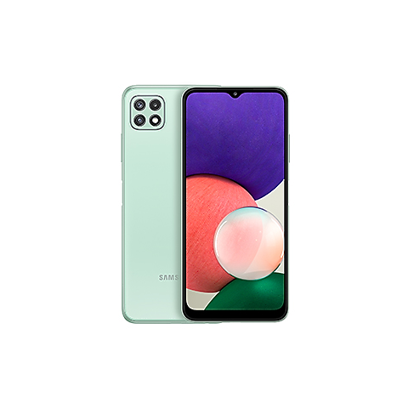

Fig. 3: Samsung Galaxy A22 5G Model

**3.2.2 LYF Water F1**

Dimensions: 4.53 x 2.55 in

Display Type: Super AMOLED, 90Hz, 600 nits (HDR)

Size: 5.2 inches

Resolution:1080 x 1920 pixels

OS: Android Marshmallow 6.0

Back Camera:

Quad: 16MP

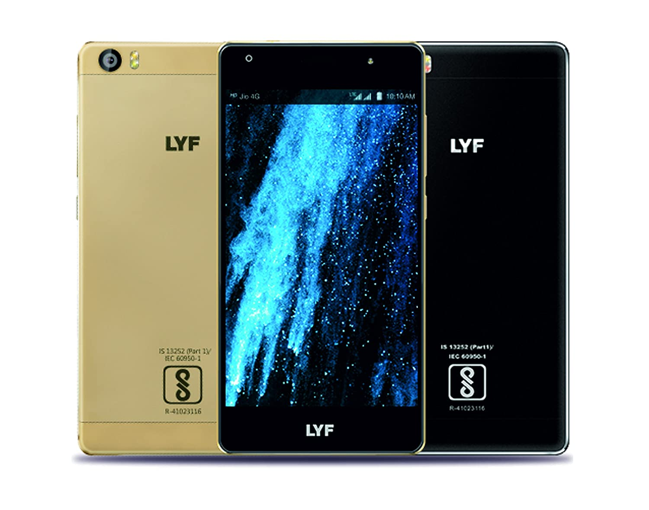

Fig. 4: LYF Water F1s Model

**Chapter 4: Implementation Work Details**

* 1. **REAL LIFE APPLICATION**

It is a commonly known fact that most people do not track their expenses and finances. By finances, in this report, we are referring to keeping track of small and often forgotten day-to-day expenses.

Keeping a check and record for all major expenses and transactions is crucial. But more often than not, this ignorance of minor expenditures leads to bewildering consequences. It can cause exceeding credit card limits, accumulated debts, and as per the Life Hack website, even cause family rifts alongside daily stress, anxiety of the future. It can leave one feeling confused and incompetent of self-dependency.

The residual feeling of being lost, when swelled, can make one feel as if they are in the backseat of their own lives, while fear and stress remain the only driving factor and causes of their consequent actions.

Taking out mere minutes daily from the hectic and overloaded schedules can help people work on these issues. It can act as a precautionary step from unrequited problems.

While feeling confident and when taking charge of your destiny, life seems like a better experience altogether.

Using Opulence: our expense tracker, the end-user would be able to avoid all of the already mentioned issues by following a set of simple steps religiously. Indeed, it is tough to incorporate habits like journaling, diary writing, and logging into your daily routine; but once in place, these habits can act as life-savers and efficiency managers.

Once you make our app a part of your everyday life, the inculcated habit of expense-tracking will help you achieve 'opulence' progressively. Life is all about taking baby steps towards becoming a better version of ourselves, and so is our application, Opulence.

* 1. **DATA IMPLEMENTATION AND PROGRAM EXECUTION**
     1. **APP FLOW**
* login/ sign up landing page
  + Login
  + Sign up
* Home page
  + Mention total budget of the time period (default: Month)
  + Budget vs spent pie chart
    - Category-wise pie chart
  + Day-wise line chart (clickable)
    - Lands to the day wise expenditure per category
  + Searchable transactions
    - Using filters
      * title
      * Category
      * Date
* Budget details
  + Main amount (probably the base amount every month or week or so…)
  + Add incoming
  + Carry-forward left amount/ or scratch off
* Category Listing
  + Default preset listing
    - Food, clothing, rent, stationary, etc.
  + How to add more
    - Label,
    - Custom symbol/ emoticon
    - Ability to set an upper limit
  + Category wise analysis
    - line charts of expenditures in the set duration (default: month)
    - Amount left to reach the peak amount
* Transaction detail page
  + Title
  + amount
  + Date
  + Category
* Transaction summary page
  + Table of transactions
* Add transaction
  + Scan
    - Scan receipt
    - Total amount detected
    - Move to manual sub-point 2
  + Manual
    - Details entry page
      * Title
      * Category
      * Cross-check final amount
  + If the receipt is scanned, do you want to save?
* Previous transactions receipt catalogue
  + Cloud backup account
    - Display current
    - Change option
  + Local machine
* Calendar
  + Monthly details of subscriptions/ bills
  + Add timely notification
* Account Details
  + Manage profile
    - Name
    - Email/ phone
      * Option to change
    - Password
      * Reset
      * Forgot password
* Settings
  + Themes
  + Notifications
    - Types (Enable/ Disable)
      * Upper limit reminders
      * monthly/ set-duration repetitive transactions
    - Sounds
    - Block all notifications
  + Delete account
* About us
* Feedback
* Help
  + Tutorial prototype
* Privacy policy
* Terms and conditions
* Copyright statements
  + 1. **CONTRIBUTION TO SOCIETY**

As college students, one of our biggest concerns is how to manage our allowance money while being away from the watchful eye of our parents.

Even though at the time of its inception, we primarily had hostellers and university students as our target audience, our user research has helped us make better decisions.

As stated earlier due to the expanse of the similar applications already in existence, we wanted to deliver something that would help us stand out and will be of use to our user audience.

Hence, we have decided to include a text extraction model which would help the user to scan a receipt to input the total price as well as to keep record simultaneously.

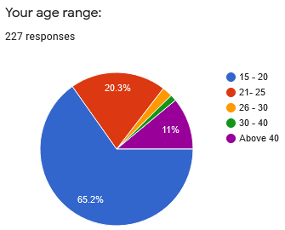

Fig 5: Survey Question – Your age range

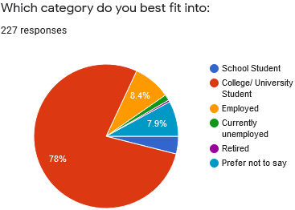

Fig 6: Survey Question - Which category do you best fit into?

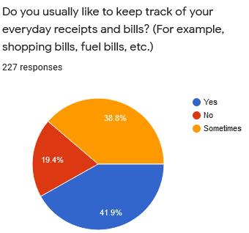

Fig 7: Survey Question – Do you usually like to keep track of your everyday receipts and bill?

**Chapter 5: Code Snippets**

**5.1**  **Widgets**

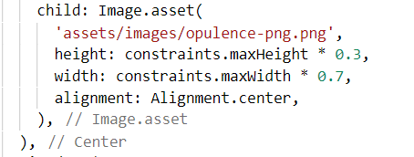

Fig 8: Logo Placement on Landing Page

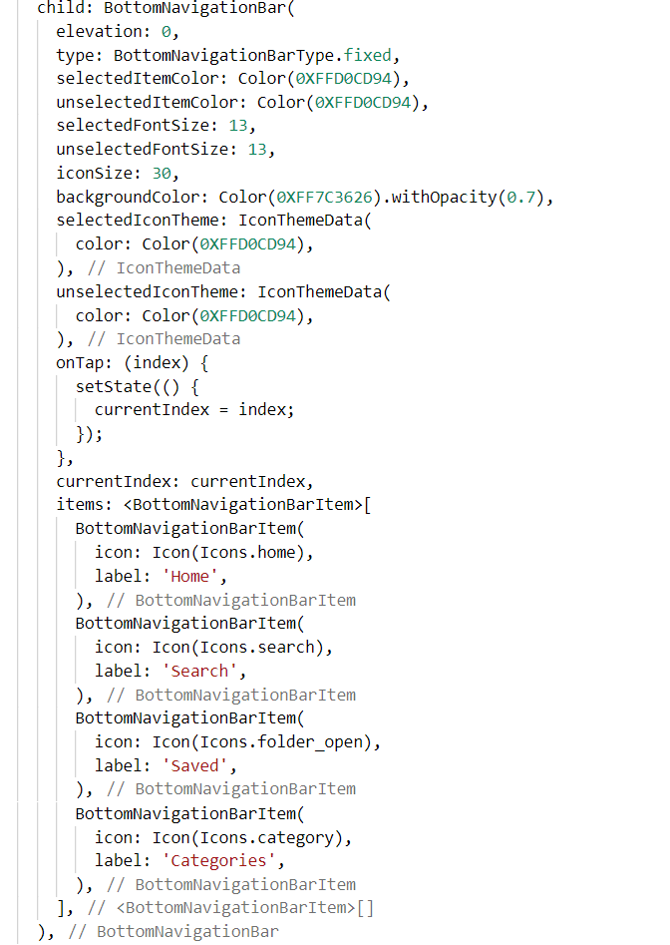

Fig 9: Bottom Navigation

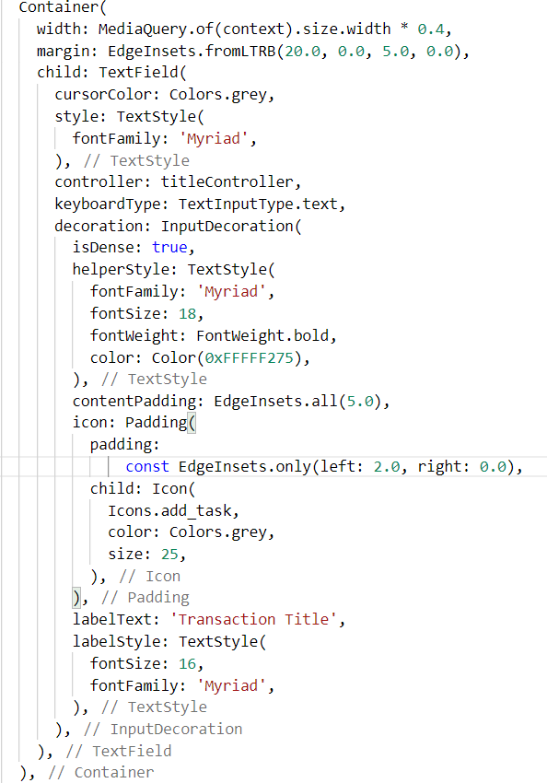

Fig 10: Transaction Detail Widget – Transaction Title

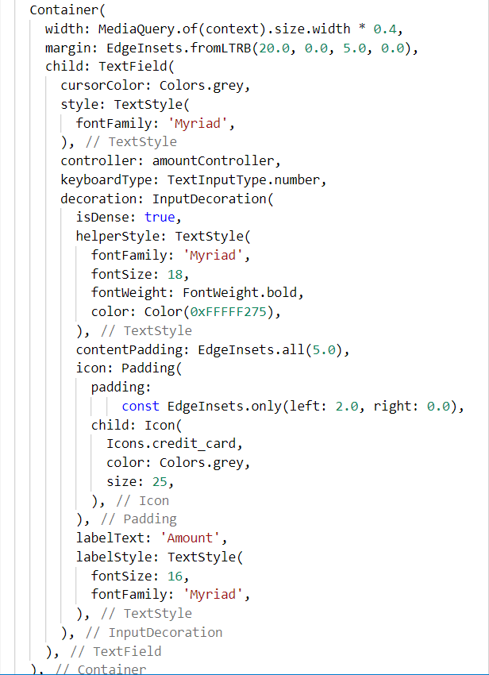

Fig 11: Transaction Detail Widget – Amount

**Chapter 6: Input/Output Screens**

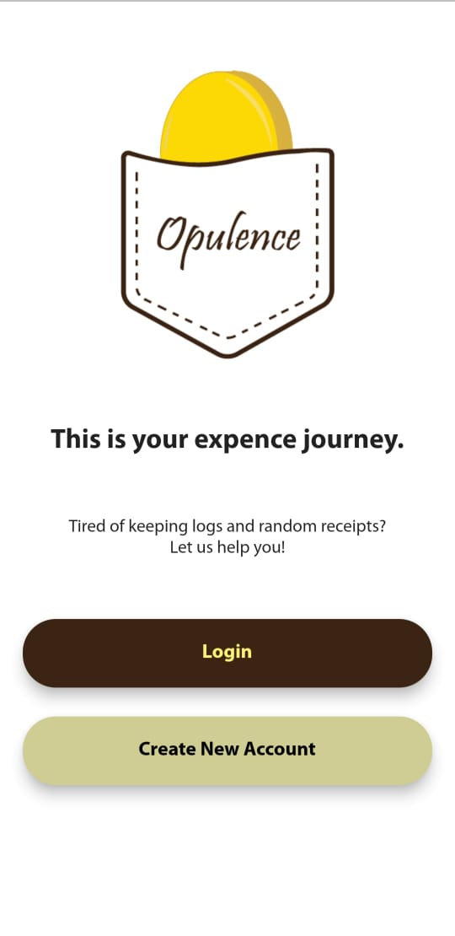 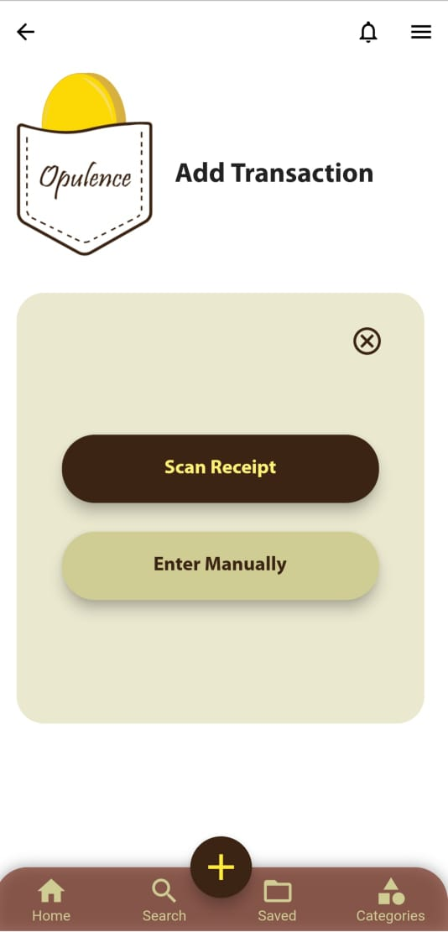

Fig 13: Add Transaction Page of Opulence

Fig 12: Sign In/ Sign Up Page of Opulence

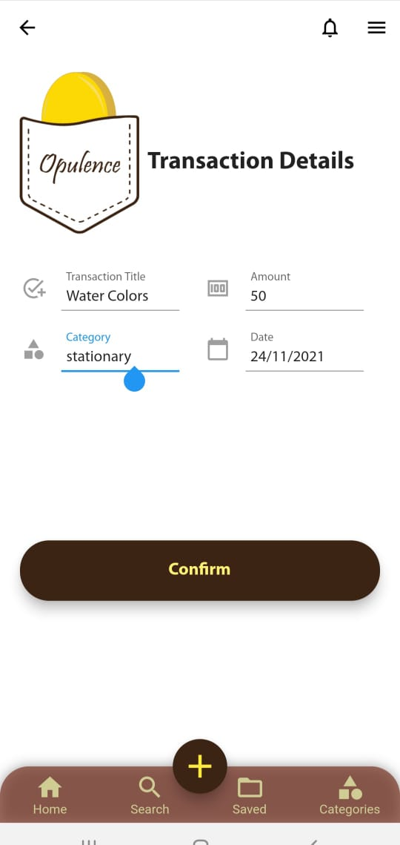 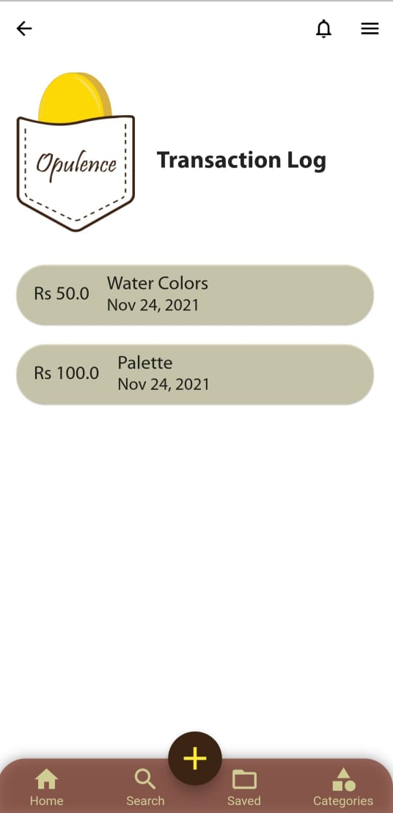

Fig 15: All the Transactions added by the user are displayed on this page

Fig 14: Manual Add Transaction Details Page of Opulence

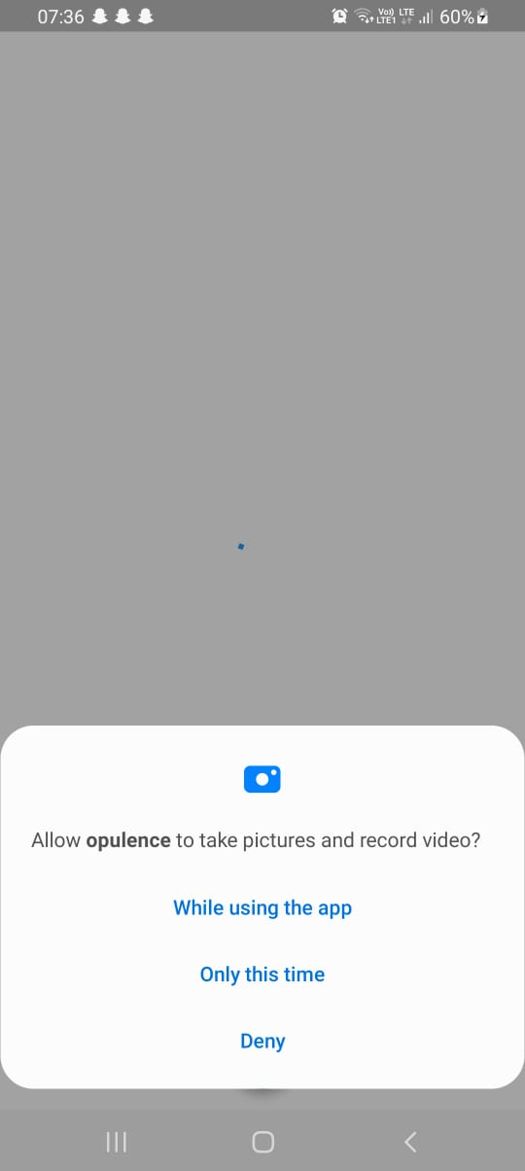 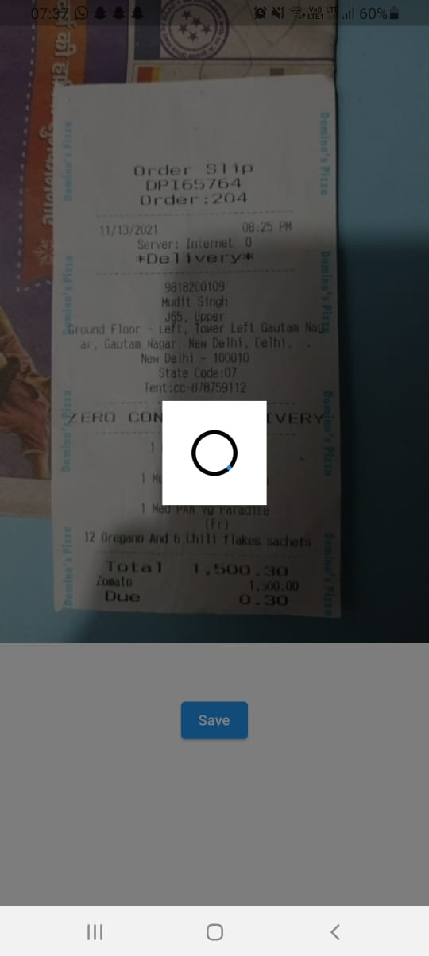

Fig 17: Saving the image clicked

Fig 16: Asking for camera access

 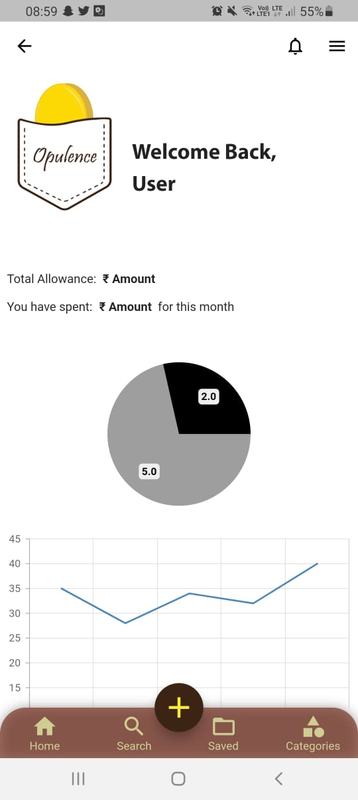

Fig 19: Home Page

Fig 18: Loading Page

**Chapter 7: System Testing**

* 1. **MULTI MEDIA QUERY**

Dynamic screen sizing enables the application to work equally feasibly on all screen sizes, maintaining uniformity throughout.

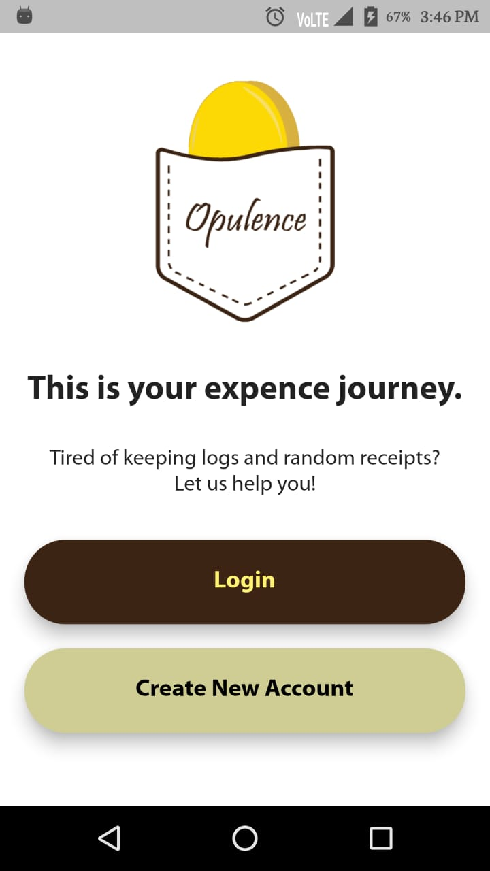 

Fig 21: Samsung Galaxy A22 Screen

Fig 20: LYF Water F1 Screen

* 1. **SCAN FEATURE ACCURACY**

The Google ML Kit uses vision API with an accuracy of 98 percent. But as we have a custom-coded model in the ML Kit, the accuracy of our model is around 80 percent.

**Chapter 8: Individual Contribution**

**Bhakti Yadav**

Bhakti is a meticulous, hard-working member. She was responsible for exploring and formulating on the backend of the application. She has worked on the entire Flutter codebase of the project. She took up the challenge of learning an entirely new technical stack for the only purpose of this project and, well, the curiosity and drive to learn something different. A diligent member, Bhakti has been aware and present throughout the design process of the project.

She has tested and stretched her limits for the project. Also, she has never failed to keep the other members reminded of the schedule to follow. She has proved to be an integral part of the group.

**Deepansha Singh**

Deepansha is the conscientious one of the group. An ironic nagging perfectionist and a risk-taker, she was responsible for the designing and prototyping processes of the application.  Being a keen research enthusiast of Human-Computer Interaction, she was able to apply the theoretical knowledge of user psychology and the bustling trends of the fields of UI/ UX while maintaining a practical balance effectively.

She has been actively managing and keeping the members accountable for their share of the work. Taking charge of the activities and progress, she worked on keeping the group in the loop for each member's progress. Having a definitive personality, she was the unsaid log-keeper of our logging application.

**Samyukta Singh**

Samyukta is the spark and bridge of the group. A machine learning enthusiast, she was responsible for the model creation and integration of the scan feature into the application. She has a laid-back approach to work while comparing and contrasting whatever she does to the plethora of resources available. Per her approach, she has never failed to amaze the rest of the members by silently working and checking off tasks in her to-do list without boisterous celebrities.

She has worked hard while trying and testing various technologies and pre-published software that could be used to make the scan feature more and more efficient and effective. She is the driving force behind the most prominent feature that our application boasts.

**Chapter 9: Conclusion**

There is a saying that “the easiest way of becoming bankrupt is by not paying attention to your expenses.” There is nothing that expresses the significance of keeping track of your expenses better than that saying.

The responsibility of taking care of your finances doesn’t ensue when you begin making money from your job. It starts much earlier; for some when they get to college and for others even earlier. If you don’t learn to manage your resources earlier in life, you may find it harder to adopt proper monetary habits later when you begin to earn.

Hence, we bring for you our flutter-based mobile application to help to track your monetary resources.

* 1. **LIMITATIONS**

Everything has its limitations, and so does our application.

Suppose you went out with your friends to have some fun and then went to dinner. You get the bill for dinner and decide to split it accordingly. But while creating an entry for this bill, the value stored in the log would be the total amount of the bill. There is no way to split the bill in unequal numbers.

Another limitation of the application is that you cannot link your google accounts to your opulence accounts yet. It could have made login an effortless process for the user.

* 1. **SCOPE FOR FUTURE WORK**

We hope to clear away the above-stated points from the list of limitations and add these as features in the later versions of our application.

We also wish to make a community on Opulence where you can connect easily with your friends and track who owes whom money.

To make the application more interactive, we plan to introduce the concept of avatars for each user.

**Chapter 10: Bibliography**

[1] Google PlayStore Search Results [Online]. Available: https://play.google.com/store/apps/collection/cluster?clp=ggERCg9leHBlbnNlIHRyYWNrZXI%3D:S:ANO1ljLy5C0&gsr=ChSCAREKD2V4cGVuc2UgdHJhY2tlcg%3D%3D:S:ANO1ljI3h8w&hl=en_US&gl=US

[2] *Android Definition*, TechTerms.com [Online]. Available: https://techterms.com/definition/android

[3] *Flutter Documentation* [Online]. Available: https://docs.flutter.dev/

[4] *Dart Documentation* [Online]. Available: https://dart.dev/guides

[5] *ML Kit* [Online]. Available: https://developers.google.com/ml-kit

[6] *What is OCR and What is it used for?*, docparser [Online]. Available: https://docparser.com/blog/what-is-ocr/

[7] *SDK vs API: What’s the difference?*, IBM Cloud Education, IBM Cloud [Online]. Available: https://www.ibm.com/cloud/blog/sdk-vs-api

[8] *What is SDK*, Red Hat [Online]. Available: https://www.redhat.com/en/topics/cloud-native-apps/what-is-SDK

[9] *Application Programming Interface (API),* IBM Cloud Education [Online]. Available: https://www.ibm.com/cloud/learn/api

[10] *What is an API?,* MuleSoft [Online]. Available: https://www.mulesoft.com/resources/api/what-is-an-api#:~:text=API%20is%20the%20acronym%20for,you're%20using%20an%20API

[11] *Java Documentation,* Oracle [Online]. Available: https://docs.oracle.com/en/java/

[12] *Apache Groovy*, The Apache Software Foundation [Online]. Available: https://groovy-lang.org/

[13] *Difference between static & dynamic programming languages?*, SSDN Technologies [Online]. Available: https://www.ssdntech.com/blog/difference-between-static-and-dynamic-programming-languages/%23:~:text=Statically%20Programming%20Language%3A,be%20used%20in%20our%20code.&text=Once%20we%20have%20define%20the,variable%20into%20another%20data%20type

[14] *Dynamic Programming Language*, MDN Web Docs [Online]. Available: https://developer.mozilla.org/en-US/docs/Glossary/Dynamic_programming_language

[15] *The Jupyter Notebook,* Jupyter Team [Online]. Available: https://jupyter-notebook.readthedocs.io/en/stable/notebook.html

[16] *GitHub,* GitHub [Online]. Available: https://github.com/about

[17] Liubomyr (El.) Kachur, *5 Reasons Why Devs Love GitHub (And Microsoft Buys It),* DZone [Online]. Available: https://dzone.com/articles/5-reasons-why-devs-love-github-and-microsoft-buys

[18] Jenny Bryan, *Why Git? Why GitHub?,* happygitwithr.com [Online]. Available: https://happygitwithr.com/big-picture.html

[19] Richard Klein, *Importance of Keeping Track of Your Expenses,* Long Island CPA Firm [Online]. Available: https://richardkleincpa.com/importance-of-keeping-track-of-your-expenses/

[20] Figma [Online]. Available: https://www.figma.com/

[21] Adobe Illustrator [Online]. Available: https://www.adobe.com/products/illustrator.html

[22] Google Forms [Online]. Available: https://docs.google.com/forms/u/0/

[23] Sharen Ross, *5 Surprising Benefits of Tracking Your Spending,* Lifehack [Online]. Available: https://www.lifehack.org/482228/5-surprising-benefits-of-tracking-your-spending

[24] Priya Pedamkar, *What is Visual Studio Code?,* Educba [Online]. Available: https://www.educba.com/what-is-visual-studio-code/

[25] Visual Studio Code, Microsoft [Online]. Available: https://code.visualstudio.com/

**Chapter 11: Annexure**

* 1. **Plagiarism Report**

